**Interim Report of**

**Orders Data Analysis**

**Steps to Download and Run the queries:**

1. Download the .sql file from the GitHub repository.
2. Open the downloaded file in MySQL Workbench.
3. Run the basic Commands like Create database, create table, insert command to create the database, create table in the database and load the data to the tables.
4. Once all these commands are executed, the database with the tables are created with the entries in it.
5. Finally run all the queries one by one in the file which gives you the results according to questions.

**Sample of all the tables:**

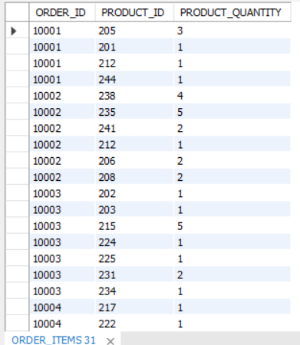

fig no 1: Sample of the Order Items table in the dataset

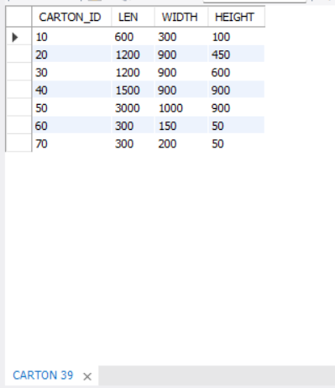

fig no 2: Sample of the Carton table in the dataset

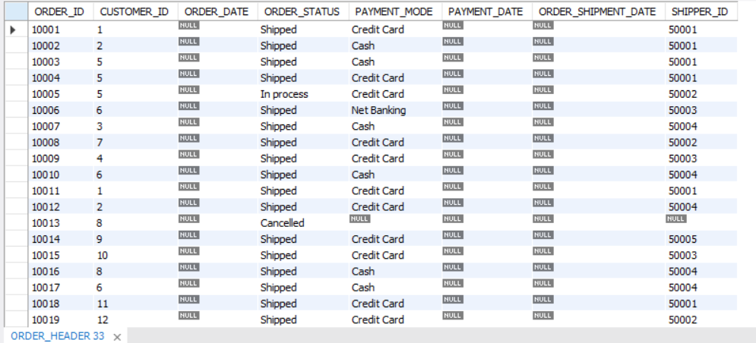

fig no 3: Sample of the Order Header table in the dataset

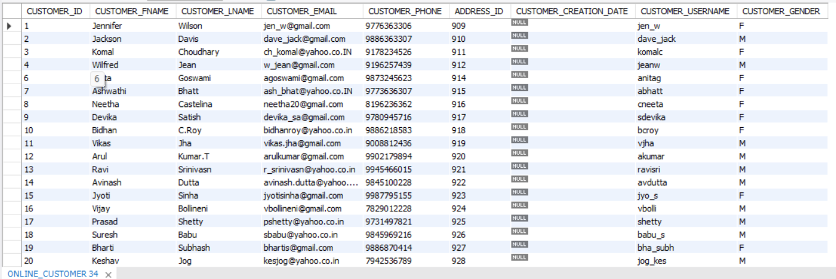

fig no 4: Sample of the Online Customers table in the dataset

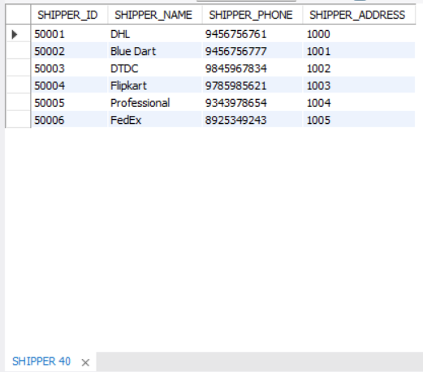

fig no 5: Sample of the Shipper table in the dataset

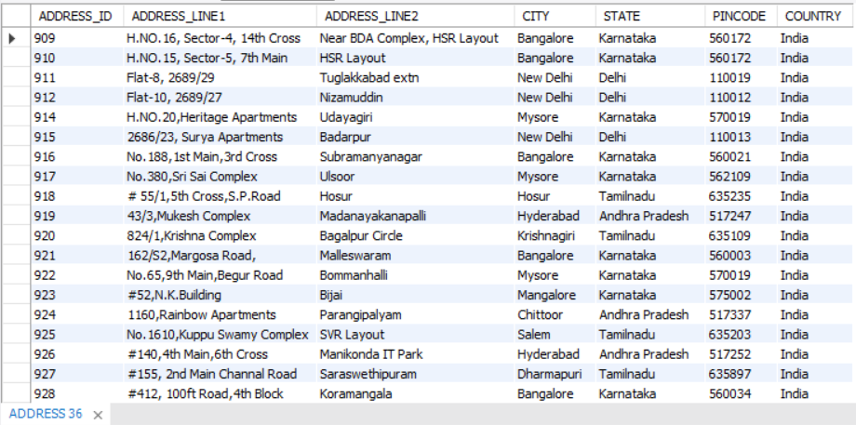

fig no 6: Sample of the Address table in the dataset

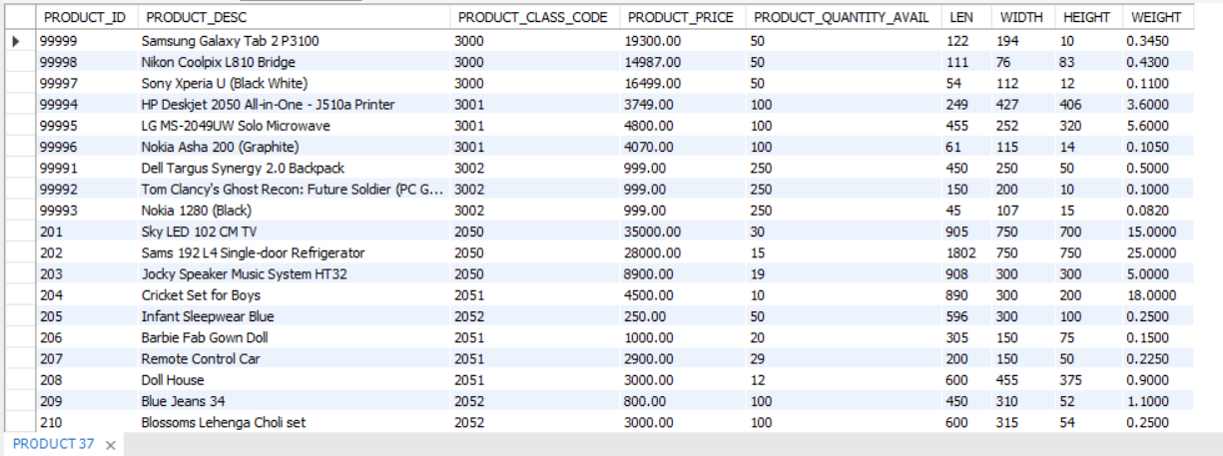

fig no 7: Sample of the Product table in the dataset

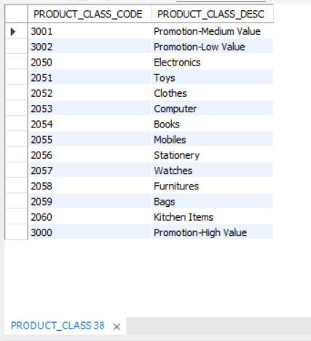

fig no 8: Sample of the Product Class table in the dataset

**Note: The above figures are just the sample images of the table, the whole result of checking all the records in the table is exported into CSV and shared in the folder with the table names.**

**Count of the records in all the tables:**

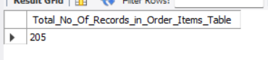

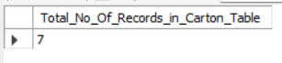



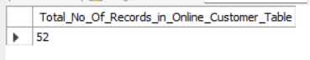

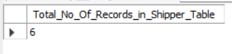

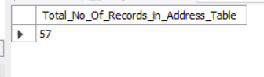

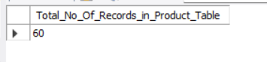

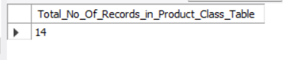

fig no 9: Total Number of records of all the table in the dataset

**The Total Sum and the Average Value of the Numerical Colum – Product_ Price from Product table:**

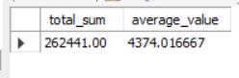

fig no 10: Total sum and average value of Product Price

Note: This image is obtained by executing the query which is shared in the .sql file. By running the query this output can be seen in the MySQL Workbench.

**The Solutions of few questions with the question numbers:**

**Solution to Question 3:**

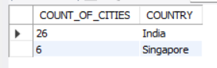

fig no 11: Solution to Question 3

**Solution to Question 5:**

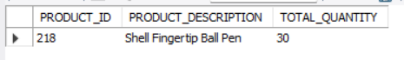

fig no 12: Solution to Question 5

**Solution to Question 7:**

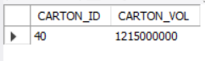

fig no 13: Solution to Question 7

**Solution to Question 8:**

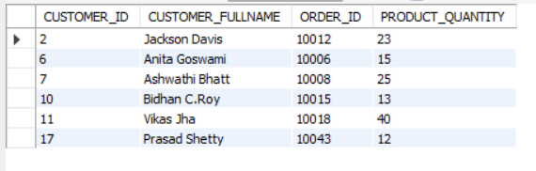

fig no 14: Solution to Question 8

**Solution to Question 9:**

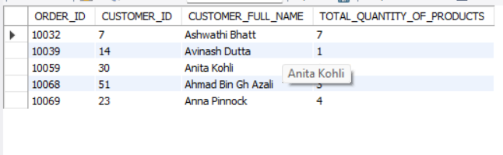

fig no 15: Solution to Question 9

**Solution to Question 10:**

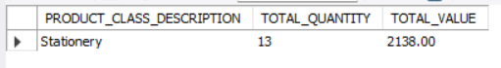

fig no 16: Solution to Question 10

**Note: All the questions and the queries related to the questions are clearly present in the .sql file. As many of the results cannot be captured in the screenshots, the results are stored in CSV files and uploaded in the repository.**